GANGES JUTE PVT. LTD.
(BAG UNIT)
(Employee Handbook)

Dated of Issue: 28.01.2016
Revision date – 01.01.2026
Issue No. : 02, Revised: 02

APPROVED BY
GENERAL MANAGER
Shyamnagar,
Garulia

This document and the information contained therein is the property of M/s Ganges Jute (P) Ltd. It must not be reproduced in whole or in part, in any form whatsoever, without the prior formal consent of Ganges Jute (P) Ltd.

GANGES JUTE PVT. LTD.

INTRODUCTION

Induction Training plays a very important role in preparing entrants’ in the company fulfilling their responsibilities.
The given manual aims at supporting the entity based on specific policies and system for learning and engagement of new employee, according to the responsibilities and work nature of each authority. There is included in the guide the vision, mission and objectives of the entity along with the organizational structure and alternate modes of operation and step by step procedures for system access.
The mission of Ganges Jute Pvt. Ltd is to be the leading jute products manufacturer in terms of quality, efficiencies, and margins by managing our partners, customers and associates in a productive and efficient manner.
Our vision is to reach a wide array of quality jute products to newer markets and regions of the, to popularize the use of this eco-friendly versatile fiber and to take it to the prominent position it truly merits.

INDEX

GANGES JUTE PVT. LTD. 2
INTRODUCTION 2
1. OBJECTIVE 5
2. OBJECTIVE OVERVIEW 6
History and Growth of this Group 6
Management 6
ABOUT: 7
ORGANIZATIONAL CULTURE 8
Certification/Accreditation 9
Bag Photo 10
3. KEY INFORMATION FOR EMPLOYEES 13
Ethical Recruitment Practices 13
Comprehensive Worker Protection & Child Labor Prevention 14
Women Development, Support for Minorities, Vulnerable Groups, and Disability Inclusion 15
Transparent & Equitable Remuneration Process 16
HEALTH AND SAFETY MEASURES 18
Workplace Harassment Prevention and Monitoring 19
Employee Benefits & Compensation Package 19
Internal Mobility Policy 21
GENERAL SECURITY PRACTICES 21
Document Retention Policy & Employee Identification Security 22
4. ORGANOGRAM WITH ROLES AND RESPONSIBILITIES 24
1. Executive Director 24
2. Director-Marketing 24
3. Sales Manager 24
4. Purchase Manager 24
5. Purchase Officer 24
6. General Manager 25
7. Production Manager cum HSCO 25
8. Production Head Cutting 26
9. Production Head Printing 26
10. Production Head Stitching 26
11. Production Head Packing 27
12. Mechanical Assistant 27
13. Quality Control Officer 27
14. Shipping Assistant 27
15. Stores Officer 28
16. Material Receiving Assistant 28
17. Dispatch Section Assistant 28
18. Commercial Manager & HR 28
19. Compliance Officer 29
Organogram with Responsibility & Authority 30
5. LAY OUT OF FIRM’S OPERATIONAL FACILITY 31
Procedure for Cutting Operation 31
6. HANDLING COMPLAIN AND SUGGESTION: 35
7. MONITORING OF INTERNAL CONTROLS AND EFFECTIVENESS 37
8. GREVIANCE & REMEDIATION MECHANISM 39
Grievance Mechanism 39
Remediation Procedure for Specific Issues 41
9. WHISTLEBLOWER PROCEDURE 43
10. LIST OF POLICIES 45
SUMMARY 46

OBJECTIVE

The present manual is designed to provide advice and to support the organization in updating their Induction programs for the new employee ,so they become an integral part of the personnel at the entity .This manual gives the new employee a chance to know and understand the company, and ensure the commitment of both parties to performance, efficiency , and contribution to creating a productive and motivating workplace.

The First revised and enlarged edition of the book includes a separate section of organizational culture, roles and responsibility,

This manual of the Induction Training for New Employee aims at:
- Building a new work culture at the organization which is based on
transparency, performance and productivity.
- Documenting the most important procedures related to the induction training for new employees.

OBJECTIVE OVERVIEW

History and Growth of this Group

Ganges Jute Pvt. Ltd has an experience of 80 years in manufacturing and marketing a diverse range of jute products, comprising traditional jute items as well as diversified modern jute products. The company’s continued commitment to customer oriented approach and quality control measures have enabled us to offer this golden fiber for multi-dimensional use to many satisfied customers.

Management

Efficient management of a continuously running this Bag Unit demands judicious manpower planning, selection of qualified and experienced personnel and an appropriate organization structure, clearly defining the function and responsibilities of managerial and supervisory staff in such diverse areas as administration, finance and budgetary control, purchase and sales, operation and maintenance, quality control, personnel management, plant security, etc.
The Board of Directors of Ganges Jute is constituted of technical, financial and business experts in the jute sector.

ABOUT:

- Ganges Jute Pvt. Ltd. (GJPL) is the youngest mill amongst the four Jute mills owned by The Ganges Group having a history and experience of over 80 years in manufacturing of Jute products.

- GJPL is a customer focused, forward-thinking, progressive manufacturer and exporter of jute diversified products and a Government recognized Star Export House.

- Efficient Management of a continuously running jute mill demands judicious manpower planning, selection of qualified and experienced personnel and an appropriate organization structure, clearly defining the function and responsibilities of managerial and supervisory and sales, operation and maintenance, quality control, personnel management, plant security etc.

- Firm recognize the socio-ethical responsibilities and effective implementation as part of the corporate culture.

- Firm have been following the ETI Base Code that sets out the targets for our ethical and social compliances.

- Company also implements and maintain Organizational, Social, Environmental and Ethical Policy.

ORGANIZATIONAL CULTURE

A great organizational culture is the key to developing the traits necessary for company’s success. Organization cannot function with different teams working in their own style and strategy lined towards its vision. Hence, every employee has to work towards the common goal with the set guidelines, process, and procedures.
According to Alan Adler, “Organizational Culture Is the Civilization In The Workplace”.
OUR COMPANY’s CULTURE
We ‘re a team of self-starting, mission driven individual with a passion for purposeful innovation. As we continue to grow rapidly, we’re always on the lookout for problem solving, big thinkers to come aboard!
At GANGES, our most valuable resource is our people---with a diversity of backgrounds, ideas, options and life experiences. We hire smart, creative, passionate professionals who are always learning and teaching. Our culture is one that supports, encourages and looks to expand and build it constantly. From competitive salaries and benefit packages, we offer employees benefits that improve their personal lives as well as their careers. We are committed to creating a culture of inclusivity, where there are opportunities for all, everyone feels like they belong, and different perspectives are valued. Everyone on our team is involved in our company’s vision and success, and we believe that the diverse voices at our company strengthen us as a team and improve our product. We encourage our employees to bring their best selves to work, and given the resources and opportunity to realize their own personal success. Our culture fosters an environment that rewards employees based on merit and performance, and not tenure. We value integrity, transparency and accountability. We believe that more trust+ more autonomy+ more humanity= more success. We value what makes you different and encourage you to act on your ideas.
At GANGES, opportunities to shine happen daily. You bring skills and customer- first mentality, and we’ll bring the tools and environment you need to do the best work of your life.

Certification/Accreditation

- BRC (British Retail Consortium)
- ISO 9001:2008 (Quality Management System)
- ISO 14001:2004 (Environment Management System)
- ISO 45001:2018 (Occupational Health & Safety)
- SA 8000:2014 (Social accountability)
- SMETA
- GOTS (Global Organic Textile Standard)
- OCS (Organic Content Standard)
- BSCI
- GRS (Global Recycle Standard)
- Oeko – Tex
- Fairtrade
- BCI (Better Cotton Initiative)
- SCS
- FCCA
- Merlin Social Audit
- ALDI Technical

We are the member of the following association

- JMDC (Jute Manufactures Development Council)
- EPCH (Export Promotion Council for Handcrafts)
- IJIRA (Indian Jute Industries Research Association)
- TEXPROSIL
- SEDEX (Supplier Ethical Data Exchange)

Bag Photo

Company Profile

Name of the Company : Ganges Jute (P) Ltd. (Bag Unit)

Date of Establishment : 28-08-2007

Registered Office : Chatterjee International Centre,
33A, Jawaharlal Nehru Road,
Flat No. A-5, Kolkata-700 07

Site Location : Dr. M.M. Banerjee Road
Shyamnagar South Jute Mill Compound,
P.O. Garulia, PS.- Noapara
North 24 Parganas, Pin-743133
West Bengal

Nature of Business : Manufacturing of shopping and
Promotional bag made with Jute, Juco
and Cotton.
Production Capacity : 50,000 bags per day

Total employees Strength : 425 (317 male & 93 female)

1.5 FLOOR AREA: -
DESCRIPTION OF FLOOR AREA: - | SQ. ft. | SQ.m
PRODUCTIONS FLOOR | 56,757 | 5,274.81
WARE HOUSE | 12,768 | 1,186.62
STORE | 11,176 | 1,038.66
CANTEEN & OTHERS | 5,453 | 506.81
OFFICE | 2,336 | 217.10
OPEN AREA | 21,500 | 1,998.00
TOTAL | 109,990 | 10,222.00
Applicable Legal & Environmental Laws and Act

- Factory Act 1948
- Minimum wages Act 1936
- Maternity Benefit act, 1961P
- Payment of Bonus Act, 1965
- Employees’ State Insurance Act, 1948
- The Employee’s State Insurance Act,1948
- The Environment (Protection )Act,1986
- The Water (Protection and Control Pollution) Act, 1974 and the Water (Prevention and Control of pollution) Rules, 1995
- The Air (prevention and Control of Pollution) Act 1981, and the Air (prevention and Control of Pollution) Rules, 1995.
- The Hazardous Waste (Management and Handling) Rules, 1989
- The Manufacture, Storage and Import of Hazardous Chemical Rules, 1989.

KEY INFORMATION FOR EMPLOYEES

Ethical Recruitment Practices

- Job Posting and Initial Screening
- Development of clear, non-discriminatory job descriptions adhering to SA8000 standards
- Wide distribution of job postings through diverse channels to ensure a varied applicant pool
- Initial screening of applications based solely on qualifications and experience
- Implementation of blind resume review process to minimize unconscious bias

- Age Verification and Documentation
- Strict enforcement of minimum employment age (14 years) in compliance with national laws and SA8000 standards
- Mandatory submission of standard age proofs (birth certificates, government IDs) for all applicants
- Rigorous verification process applied to all employees, including subcontracted staff
- Collaboration with local authorities to verify document authenticity when necessary
- Regular audits to ensure ongoing compliance with age verification procedures

- Interview and Selection Process
- Structured interview process with standardized questions to ensure fair evaluation
- Panel interviews to minimize individual bias and provide diverse perspectives
- Skill-based assessments and job-related tests to objectively evaluate candidate capabilities
- Comprehensive training for hiring managers on fair selection practices, SA8000 compliance, and recognizing and preventing discrimination
- Secondary verification of age and qualifications during the interview stage

- Job Offer and Onboarding
- Clear communication of job terms, including working hours, conditions, and compensation structure
- Comprehensive orientation program covering company policies, with special emphasis on rights and responsibilities
- Tailored onboarding process for young workers, including detailed safety briefings and work hour limitations
- Assignment of mentors to new employees, especially young workers, to provide ongoing support and guidance

- Diversity and Inclusion Initiatives
- Active efforts to increase diversity in recruitment and leadership roles
- Implementation of diversity targets for hiring and promotion, with regular progress reviews
- Establishment of employee resource groups to support diverse populations
- Regular cultural sensitivity and unconscious bias training for all employees
- Creation of an inclusive work environment that values and respects diverse perspectives

Comprehensive Worker Protection & Child Labor Prevention

- Stringent Child Labor Prevention Measures
- Zero-tolerance policy for child labor, strictly prohibiting the employment of individuals under 14 years of age
- Regular training for HR, management, and all employees on identifying and preventing child labor
- Establishment of robust remediation procedures in case of accidental hiring of underage workers
- Collaboration with local NGOs and government agencies to support education and rehabilitation of child laborers if encountered

- Young Worker Protection Program
- Strict limitation of working hours for young workers: maximum 8 hours per day, no night shifts
- Ensuring combined school, work, and transportation time doesn't exceed 10 hours daily for young workers
- Implementation of a comprehensive health and safety program specifically tailored for young workers
- Regular health check-ups and safety training sessions for young employees
- Prohibition of young workers from engaging in any hazardous tasks or working in high-risk areas
- Flexible scheduling to accommodate schooling requirements and prioritize education

- Hazard Identification and Risk Management
- Development of a robust system for hazard identification and risk assessment, with special consideration for young workers
- Regular workplace safety audits and prompt addressing of identified risks
- Implementation of age-appropriate safety equipment and protocols
- Continuous monitoring of workplace conditions to ensure a safe environment for all workers, especially young employees

- Education and Skill Development for Young Workers
- Provision of vocational training opportunities to enhance skills and future employability
- Partnerships with local educational institutions to support continued learning
- Implementation of a structured apprenticeship program for eligible young workers
- Regular career counseling and guidance sessions for young employees

- Communication and Support Systems
- Clear and continuous communication of rights, responsibilities, and safety protocols to all workers, with special attention to young employees
- Establishment of an anonymous reporting system for safety concerns or policy violations
- Regular check-ins and feedback sessions with young workers to ensure their wellbeing and address any concerns
- Creation of a supportive work environment that encourages open dialogue and problem-solving

Women Development, Support for Minorities, Vulnerable Groups, and Disability Inclusion

- Empowerment and Development Initiatives
- Ganges Jute Pvt. Ltd. implements women development programs aimed at empowering female employees through various means, such as leadership training, mentorship programs, and skill development workshops.
- These initiatives are designed to enhance their professional skills and prepare them for leadership roles within the company.
- The company also provides flexible work arrangements to support work-life balance, particularly for working mothers, helping them manage their professional and personal responsibilities more effectively.

- Affinity Groups for Support and Networking
- Ganges Jute has established specific programs and actions towards the formation and continuity of affinity groups for minorities and vulnerable employees in the workplace. This includes affinity groups for working parents, employees of specific gender identities, and dedicated ethnic, religious, and cultural groups.
- These groups serve as platforms for networking and support, allowing employees to share challenges and successes while advocating for policies that promote diversity and inclusion.
- By facilitating mentorship opportunities within these affinity groups, the company connects less experienced employees with seasoned professionals, fostering an environment of growth and support.

- Addressing Working Conditions
- Ganges Jute actively addresses the working conditions of employees through comprehensive measures that extend beyond standard practices. This includes ensuring that working hours are structured to accommodate various employee needs, particularly for those involved in caregiving. The company provides social benefits, such as enhanced parental leave policies, childcare allowances, and access to wellness programs, ensuring equitable treatment and support for employees facing unique challenges.
- Furthermore, specific actions are taken to enable employees with a wide range of disabilities to perform their job duties. Ganges Jute has invested in accessible infrastructure, ensuring that facilities are equipped with ramps, elevators, and other necessary accommodations for physical disabilities. Additionally, the company provides specialized training programs for psychological adaptation and emotional support, helping employees with mental health challenges integrate smoothly into the workplace and thrive in their roles.

- Continuous Improvement and Feedback Mechanisms
- Regular assessments of workplace culture, along with open lines of communication for feedback, help identify areas for improvement, ensuring that all employees feel valued and supported within the organization.
- This proactive approach fosters an inclusive and supportive work environment that not only empowers women but also supports minorities, vulnerable groups, and employees with disabilities, aligning with Ganges Jute's commitment to ethical labor practices and SA8000 standards.

Transparent & Equitable Remuneration Process

- Comprehensive Salary Structure
- Implementation of a clear and transparent salary grid or matrix
- Detailed explanation of remuneration components including base salary, deductions, bonuses, and benefits to all employees
- Regular market surveys to ensure competitive and fair compensation packages
- Clear communication of criteria for salary advancement and promotion

- Performance-Based Compensation System
- Establishment of objective and measurable performance metrics for each role
- Regular performance reviews tied to compensation adjustments, conducted at least annually
- Implementation of transparent bonus and profit-sharing schemes linked to both individual and company performance
- Recognition and reward programs for exceptional contributions and innovations

- Pay Equity and Non-Discrimination
- Regular pay equity audits to identify and address any unjustified pay disparities
- Implementation of a gender-neutral job evaluation system to ensure equal pay for work of equal value
- Transparent policies on overtime, shift differentials, and additional earning opportunities
- Prohibition of wage discrimination based on age, gender, race, religion, or any other protected characteristic

- Benefits and Work-Life Balance
- Comprehensive benefits package including health insurance, retirement plans, and paid time off
- Implementation of family-friendly policies such as parental leave and flexible working arrangements
- Employee assistance programs to support mental health and work-life balance
- Regular review and update of benefits package to meet evolving employee needs and market standards

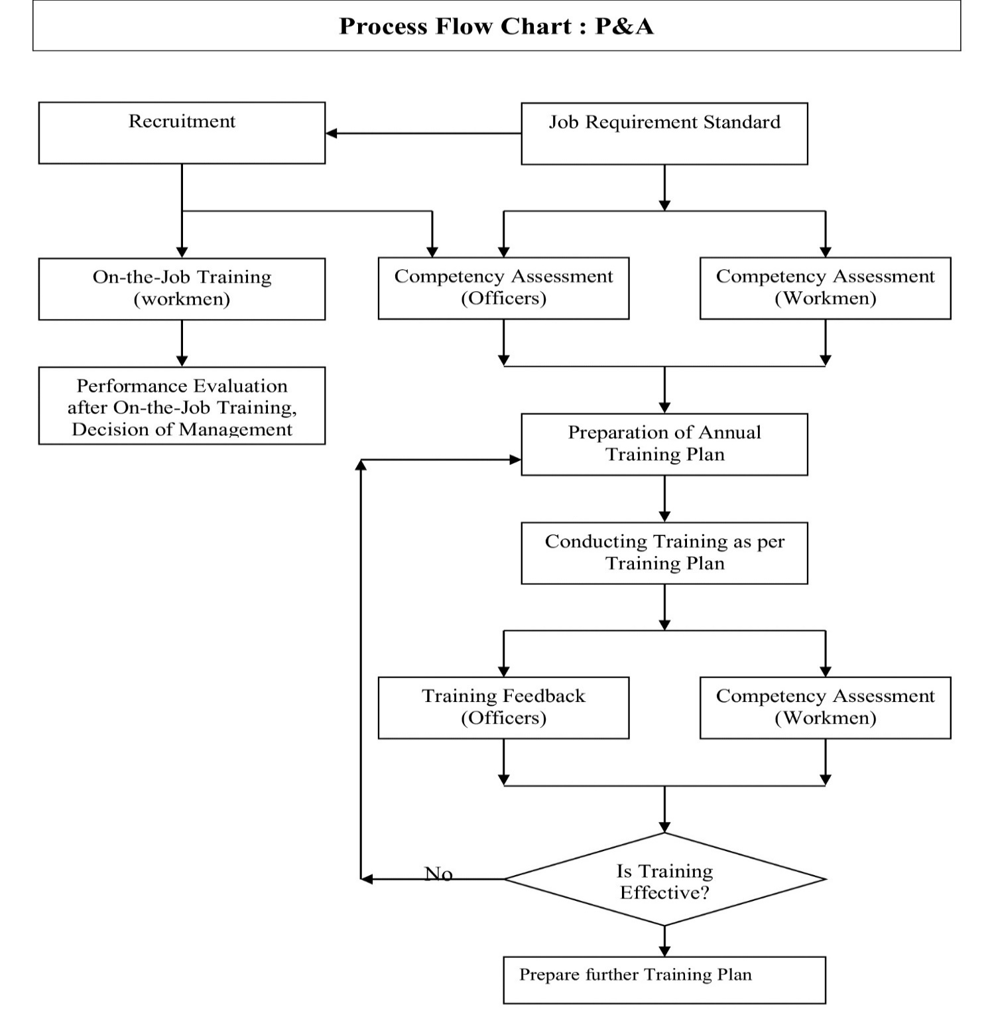

Wage Adequacy Review and Monitoring Mechanism
- Purpose and Commitment
- Ganges Jute Pvt. Ltd. is committed to ensuring that employee wages are fair, adequate, and aligned with local economic conditions, industry standards, and employee well-being.
- The company goes beyond compliance with statutory minimum wage requirements and strives to provide wages that support a decent standard of living.

- Periodic Wage Review Process
- The company conducts periodic reviews of wage levels to assess their adequacy and competitiveness.
- Wage reviews are carried out at least annually or more frequently based on changes in economic conditions.
- The review process considers internal wage structures, employee feedback, and market trends.

- Assessment Against Local Economic Conditions
Wage levels are evaluated against key economic indicators such as:
- Inflation rates
- Cost of living increases (food, housing, transportation, healthcare)
- Regional economic conditions
- Adjustments are considered to ensure that employees are able to meet their basic needs and maintain a reasonable standard of living.

- Benchmarking with Industry Standards
- The company benchmarks its wage structure against industry averages and peer organizations within the same sector and geographical region.
- External salary surveys and labor market data are used to ensure competitive and fair compensation.

- Consideration of Living Wage Principles
- Ganges Jute Pvt. Ltd. aligns its wage practices with recognized living wage principles, ensuring that wages are sufficient to cover essential needs such as food, housing, education, healthcare, and savings for unforeseen circumstances.
- The company continuously evaluates opportunities to bridge any gaps between minimum wages and living wage standards.
- Employee Engagement and Feedback
- Employee feedback regarding wages and cost of living challenges is collected through grievance mechanisms, surveys, and regular interactions.
- This feedback is considered during wage review processes to ensure practical and inclusive decision-making.

- Governance and Approval
- Wage reviews and revisions are overseen by HR and senior management to ensure consistency, fairness, and compliance with company policies and legal requirements.
- Final wage adjustments are approved by management based on review outcomes.
- Monitoring and Continuous Improvement
- The company continuously monitors wage adequacy through internal audits, compliance checks, and periodic assessments.
- Corrective actions and improvements are implemented where gaps are identified.

HEALTH AND SAFETY MEASURES

- Firm has established a set of basic rules in order to protect the health and safety of the workers. To this end, this Directive establishes obligations for employers and workers, in particular to limit accidents at work and occupational diseases. Periodic Study with applicable measure is taken to eliminate the risk factors for occupational diseases and accidents
- Employers are obliged to ensure the health and safety workers in every aspect related to their work.
Ganges Jute (P) Ltd. have established means and measures for protecting workers. These involve activities of prevention, information and training workers, particularly to:
- Avoid risks or manage those risks that cannot be avoided
- Give appropriate instructions to workers by promoting common protective measures by giving them technical training in their respective fields.
- Adapt working conditions, equipment and working methods by taking into account developments in techniques.
- The protection means and measures is adapted in cases where the Give appropriate instructions to workers by promoting common protective measures by giving them technical training in their respective fields.
- Adapt working conditions, equipment and working methods by taking into account developments in techniques.
- The protection means and measures is adapted in cases where the working conditions change. In addition, Ganges Jute (P) Ltd. Provide adequate training which is take into account the nature of the activities of the Job and the capabilities of the workers.
- We are always emphasizing in training and awareness program for protective measures and risk prevention measures for all the workers working in our farm.
- In addition, activities of first aid, fire-fighting and the evacuation of workers in serious and immediate danger are given to the employee time to time.
- The Firm establishes protective and preventative services in our company including with regard to activities of first aid and reacting to serious danger. We are given first aid training to the respective sections Staff.
- We are periodically monitoring the health of our worker.
Time to time, we consult with our employees by organizing Training and Awareness program and ask for their Feedback concerning all the issues related to health and safety at work.

Workplace Harassment Prevention and Monitoring

- Clear Anti-Harassment Policies
- Adoption of a strict zero-tolerance policy towards all forms of harassment, including physical, verbal, sexual, or psychological abuse
- Clear documentation and communication of anti-harassment policies to all employees
- Regular policy reviews to ensure alignment with national laws and SA8000 standards
- Enforcement of strict disciplinary actions for any violation, ranging from warnings to termination

- Training and Awareness
- Implementation of regular training programs for employees, supervisors, and managers on recognizing, preventing, and addressing workplace harassment
- Conducting refresher courses periodically to keep employees updated on anti-harassment protocols
- Ensuring training material is accessible to all employees, irrespective of their role or position in the company

- Monitoring and Prevention Measures
- Implementation of specific measures to prevent and monitor harassment and discrimination, beyond grievance mechanisms and training programs
- Conducting regular workplace assessments and anonymous employee surveys to identify any signs of harassment or discrimination
- Routine internal audits to ensure compliance with anti-harassment policies and proactively addressing potential risks
- Assigning designated workplace monitors responsible for ensuring a harassment-free environment by observing daily interactions and reporting any concerns

- Confidential Reporting Channels
- Provision of confidential, unbiased, and accessible channels for employees to report harassment incidents, separate from standard grievance processes
- Ensuring that employees can report incidents without fear of retaliation
- Regular follow-ups and updates on reported cases to ensure accountability and resolution

Employee Benefits & Compensation Package

- Compensation for Extra or Atypical Working Hours
- Ganges Jute Pvt. Ltd. ensures fair and transparent compensation for extra or atypical working hours in alignment with SA8000 standards. The company compensates employees for additional hours worked beyond their regular schedule, with overtime compensated at a premium rate, double the normal hourly wage, as per the Factories Act, 1948. This premium compensation applies to all forms of work exceeding or outside the contractual hours, ensuring fair remuneration for employees' efforts.
- Overtime work at Ganges Jute is strictly voluntary, and employees are not coerced into working extra hours unless necessary to meet short-term business demands. To safeguard employee well-being, overtime is capped at 12 hours per week, ensuring compliance with labor laws that prioritize health and safety.

- Leave Policy and Work-Life Balance Initiatives
- Ganges Jute provides a comprehensive leave policy, including 15-20 days of paid annual leave, based on role and tenure, and paid sick leave for recovery without income loss. The company observes all public holidays to allow employees time for family and rest.
- Beyond standard leave policies, Ganges Jute implements proactive initiatives to help employees balance work and family life. These include 16 weeks of paid maternity leave, 1 weeks of paternity leave, and additional care leaves for emergencies. The company also offers affordable childcare allowances and ensures social protection measures like maternity protection from workplace risks and protection from dismissal during parental leave.

- Organization of Work and Working Conditions
- Ganges Jute operates on a single-shift system, from 9:00 AM to 6:00 PM, Monday to Saturday, with a 1-hour lunch break and 15-minute tea break. Employees work a maximum of 48 hours per week, with regulated overtime compensated at a premium rate.
- The company goes beyond work hours and shifts to offer social benefits like health insurance and pension contributions. Regular salary reviews ensure competitive remuneration, and Ganges Jute maintains a safe, ergonomic working environment through equipment updates and risk prevention strategies.
- Ganges Jute also provides flexible working hours for certain roles, allowing adjustments to start and end times. The company promotes workplace wellness initiatives, including mental health support programs and access to counseling services, fostering a healthy and supportive workplace.

- Comprehensive Health Care Plans
- Ganges Jute provides employees with comprehensive health care plans that cover both work-related and non-work-related injuries, accidents, and illnesses. Employees and their dependents are covered through medical insurance that allows them to access medical care as soon as needed, regardless of the cause of illness or injury. This plan offers full reimbursement or coverage for hospitalization, consultations, medications, and other medical expenses, ensuring that employees and their families are financially supported during health-related issues. The company prioritizes access to medical care, allowing employees to focus on recovery without worrying about the cost.

Internal Mobility Policy

- Career Development Opportunities
- Ganges Jute Pvt. Ltd. encourages internal mobility by providing clear pathways for advancement, including vertical, horizontal, geographical, and transversal mobility, enabling employees to progress in their careers while remaining within the organization.

- Vertical Mobility
- This involves employee promotions and transfers that advance them to the next level in the organization. Ganges Jute has established a clear promotion framework that outlines the criteria and timelines for promotions. On average, the company promotes approximately 15-20 employees annually, ensuring that high-performing individuals are recognized and rewarded for their contributions.

- Horizontal Mobility
- Employees have the opportunity to change functions or departments while remaining at the same job level. This allows for diverse experience within the organization. Ganges Jute facilitates this through regular internal job postings and encourages cross-department collaboration, resulting in about 10-15 horizontal transfers per year.

GENERAL SECURITY PRACTICES

The General Security Policies as adapted by the organization is as follows:
- The Bags Division of the Company is located within a compound along with other sister organizations of the Group, however for the sake of demarcation, the entire Bags Division is segregated with Fencing around all sides and the height of such fence is a minimum of 8 feet from Ground Level.

- CCTV Surveillance Camera has been installed at strategic locations in the factory and regular monitoring of the video footage is done as a method of cross verification.

- Video footage back-up is available for a minimum period of 45 days.

- No one is allowed to enter the factory with any prohibited items like ammunitions, weapons, narcotics, alcohol etc.

- Security Guards have been appointed in the factory and they have been empowered to intercept and inspect anyone during entry and exit as well during the stay in the production facility and office area as a mark of identification of unauthorized entry or access.

- Specific inspection protocols are observed during packing of finished goods, container loading and dispatch as a security measure to prevent any chance of sabotage.

- A key control protocol and register for key issuance is maintained in the factory.

- All locks in the factory are tagged and signed off during close of factory for over 48 hrs.

- Perimeter Lighting arrangements are controlled only by the Security Guards and all areas have been fitted with Emergency Lighting Arrangements in case of accidental power failures. No other employee, apart from the Security Guards is authorized to operate the light switches.

- Employees are regularly trained on the various Policies of the organization as a measure of better implementation of the said policies.

Document Retention Policy & Employee Identification Security

- Document Retention Practices
- Ganges Jute Pvt. Ltd. follows a comprehensive document retention policy that aligns with SA8000 standards, ensuring proper management and storage of critical records. Key documents, such as employee contracts, payroll records, health and safety reports, and training logs, are retained for a minimum of 5 years or as specified by relevant labor laws and industry regulations. This retention period ensures that important records are available for audits, legal reviews, and compliance checks.
- The company maintains a formalized and detailed retention schedule that specifies the length of time each type of third-party data must be retained. For example, employee health and safety records are retained for 5 years, financial and tax-related documents for 7 years, and documents related to disciplinary actions or grievances for 3 years after resolution. The retention schedule is summarized in the table below:
Document Type | Retention Period
Employee Contracts | 5 years
Payroll Records | 5 years
Health and Safety Reports | 5 years
Training Logs | 5 years
Financial and Tax Documents | 7 years
Disciplinary Records | 3 years after resolution
Grievance Handling Documentation | 3 years after resolution
Third-Party Contracts | 5 years

- Employee Identification Document Security
- Ganges Jute has strict processes in place to ensure that employees are never required to relinquish their personal identification documents. In instances where such documents need to be submitted for verification, the company guarantees that they are immediately returned to the employees.
- Employees are provided with secure storage options, such as lockers or safes, to safely store their personal documents within the workplace. This practice ensures that employees have the means to protect their personal identification while complying with necessary administrative requirements.

- Prevention of Retention of Employee Identification Documents
- Ganges Jute Pvt. Ltd. strictly ensures that employees are not required to submit or deposit their original personal identification documents such as Aadhaar card, voter ID, passport, or any government-issued identification as a condition of employment.
- Retention of original documents by management, supervisors, or third parties is strictly prohibited.
- All employees are informed during induction and regular training programs that they have the right to retain their personal identification documents at all times.
- The company clearly communicates that no employee, supervisor, or contractor is authorized to withhold or retain such documents.
- Ganges Jute Pvt. Ltd. complies with all applicable national and local laws regarding employee documentation and identification requirements.
- Where any legal provisions apply, the company ensures that such requirements are transparently communicated to employees.
- Regular internal audits and compliance checks are conducted to ensure that this practice is consistently followed across all departments.
- Any violation of this policy is treated as a serious non-compliance and is subject to disciplinary action.

- Secure Disposal Procedures
- Once the retention period is over, Ganges Jute follows a secure disposal process for all documents, ensuring that physical records are shredded and digital records are permanently deleted. This process is critical for maintaining data protection standards and safeguarding the privacy of both employees and third parties

ORGANOGRAM WITH ROLES AND RESPONSIBILITIES

Executive Director

- Responsible for framing company’s business policy, philosophy, goals & objectives
- Overall responsible for planning & execution of short-term and long-term objectives.

Director-Marketing

- Responsible for fixing up of marketing strategies, mill operation and other commercial aspect
- Responsible for controlling of entire sales contract and sales of the company
- Overall authority and final decision maker for purchase of raw jute
- Ensuring that all specifications is adequate, accurate and in compliance with relevant safety, legislative and customer requirements.

Sales Manager
Solely, responsible for all Sales related functions :-
- Increase of sales volume.
- Keeping liaison with customers/ consumers
- Amicable settlement of customer complaints
- Evaluation of Customer Satisfaction Level and work towards betterment.

Purchase Manager

- Responsible for selection and evaluation of vendors.
- Responsible to ensure procurement of store materials according to specification and ensure their timely supply to the works.

Purchase Officer
Responsible for following functions :-
- Inviting quotations from suppliers
- Raising purchase orders to suppliers
- Evaluation of performance of suppliers

General Manager

- Responsible for day to day functioning of the unit through provision of required infrastructure in consultation with top management.
- Responsible for planning and executing of Production programs
- Overall responsible for administrative formalities related to works
- Responsible for QC section
- Overall responsibility for identification of entire requirement of factory
- Prime responsibility for maintaining quality of raw material and quality of end products
- Responsible for control of nonconforming product
- Jointly responsible for handling of customer complaints and amicable settlement.
- Functions as Management Representative and ensure that processes needed for the consumer product management system are established, implemented and maintained
- Responsible for ensuring availability of information relating to the support and monitoring of the Consumer Product Management System to relevant personnel all times
- Responsible for keeping to Top Management informed on the performance of the consumer product management system and any need for improvement
- Responsible for ensuring the promotion of awareness of customer requirements throughout the organization
- Responsible for liaising with external agencies in matters related to the consumer product management system.

Production Manager cum HSCO

- Responsible for process control of production
- Overall responsible for planning, production, proper handling, time delivery and preservation of finished goods, maintenance of Plant equipments.
- Responsible for control of nonconforming product
- Responsible for fulfillment of target production
- Responsible for coordination between production & maintenance to obtain the desired result.

Production Head Cutting

- Responsible for all Production activities including maintaining process control parameters Cutting Section by maintaining target production of all workmen under him/ her
- Responsible for maintaining discipline and in the shift
- Responsible for proper marking and identification of product
- Reports to Production Manager on the process performance
- Responsible for maintaining cutting related records and log books
- Responsible for resource management and control of nonconforming product in Cutting Section

Production Head Printing

- Responsible for all Production activities including maintaining process control parameters Printing Section by maintaining target production of all workmen under him/ her
- Responsible for maintaining discipline and in the shift
- Responsible for proper marking and identification of product
- Reports to Production Manager on the process performance
- Responsible for maintaining Printing related records and log books
- Responsible for resource management and control of nonconforming product in Printing Section

Production Head Stitching

- Responsible for all Production activities including maintaining process control parameters Stitching Section by maintaining target production of all workmen under him/ her
- Responsible for maintaining discipline and in the shift
- Responsible for proper marking and identification of product
- Reports to Production Manager on the process performance
- Responsible for maintaining Stitching related records and log books
- Responsible for resource management and control of nonconforming product in Stitching Section

Production Head Packing

- Responsible for all Production activities including maintaining process control parameters Packing Section by maintaining target production of all workmen under him/ her
- Responsible for maintaining discipline and in the shift
- Responsible for proper marking and identification of product
- Reports to Production Manager on the process performance
- Responsible for maintaining Packing related records and log books
- Responsible for resource management and control of nonconforming product in Packing Section

Mechanical Assistant

- Responsible for all maintenance activities e.g. preventive, overhauling, running, lubrication etc. for all machines and equipments
- Responsible for assisting quality of maintenance store inputs, carrying out both imports and exports
- Responsible for inventory control of needle and maintain broken needle records
- Reports to Technical Production Manager

Quality Control Officer

- Responsible for Inspection Plan as quality control of incoming, in process and finished goods
- Responsible for all Quality Control records and issuance of Test Certificates
- Responsible for monitoring, measurement and analysis of the process relating to Quality Control
- Responsible for calibration of test, laboratory and process control equipment
- Responsible for all external inspection activity
- Responsible to maintaining record of rejection

Shipping Assistant

- Responsible for all dispatch related function of the plant
- Responsible to keep liaison with production departments on dispatch related matters and with parties on dispatch related matters

Stores Officer

- Responsible for all stores related activities along with controlling and maintaining stores records
- Responsible for inventory control, preservation and verification of stores item
- Responsible for raising of Indent for purchase of stores item
- Responsible for receiving all the incoming materials and maintain records to that effect
- Ensuring proper storage and preservation of materials

Material Receiving Assistant

- Gives assistance in day to day stores activities
- Responsible for receiving all incoming materials
- Responsible to maintain Material Receiving records

Dispatch Section Assistant

- Responsible for dispatch function of the plant
- Assistance responsibility of stores activities
- Arranging day-to-day dispatch of product
- Liaison with parties and production departments on dispatch related matters
- Responsible to dispatch of materials and maintain records to that effect

Commercial Manager & HR

- Responsible for all commercial aspect
- Functions as HR manager responsible for complying with all statutory, legal requirements
- Responsible for conducting Training & conducting awareness programmes
- Responsible for maintaining social & ethical requirements
- Social Accountability SA 8000 : 2008 requirements
- Responsible for maintaining liaison with concerned govt./statutory authorities
- Responsible for maintaining industrial relationship

Compliance Officer

- Responsible for carrying out internal audit within the organization by preparation of annual internal audit plan and internal audit schedule as per requirement
- Reporting to the Top Management on the audit performance
- Overall responsibility for document control activities including maintaining of Master Copy of documents
- Authorize to change the master document as per advice of management representative
- Ensuring that the latest revision of documents are available at point of use
- Functions as Health & Safety Compliance Officer also and therefore responsible for enforcing safety practice during production and maintenance

Organogram with Responsibility & Authority

Executive Director

General Manager
Director Marketing
Purchase Manager

Purchase Officer
Sales Manager

Production Manager cum HSCO
Quality control Officer
Stores Officer
Commercial Manager & HR
Compliance Officer

Material Receiving Assistant
Dispatch Section Assistant

Cutting Supervisor
Printing Supervisor
Stitching Supervisor
Packing Supervisor
Mechanical Assistant
Shipment Assistant

LAY OUT OF FIRM’S OPERATIONAL FACILITY

Procedure for Cutting Operation
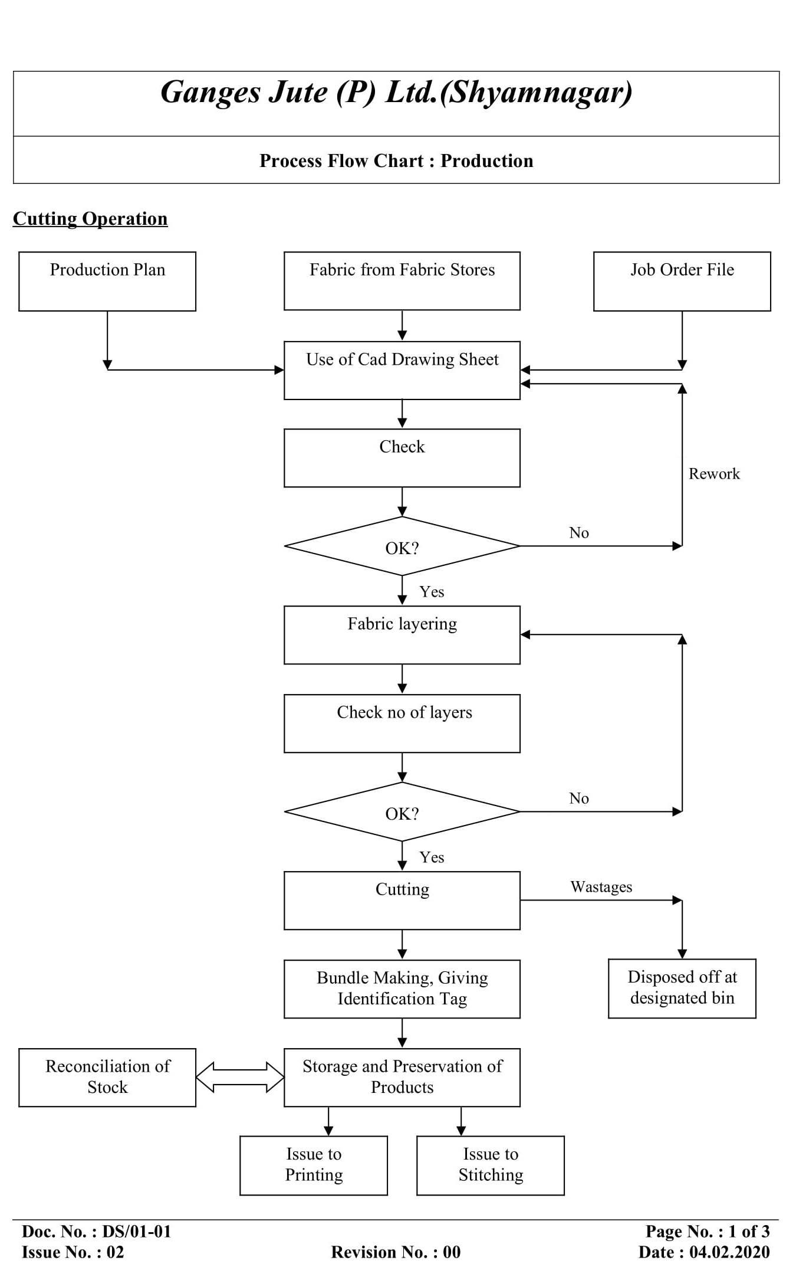
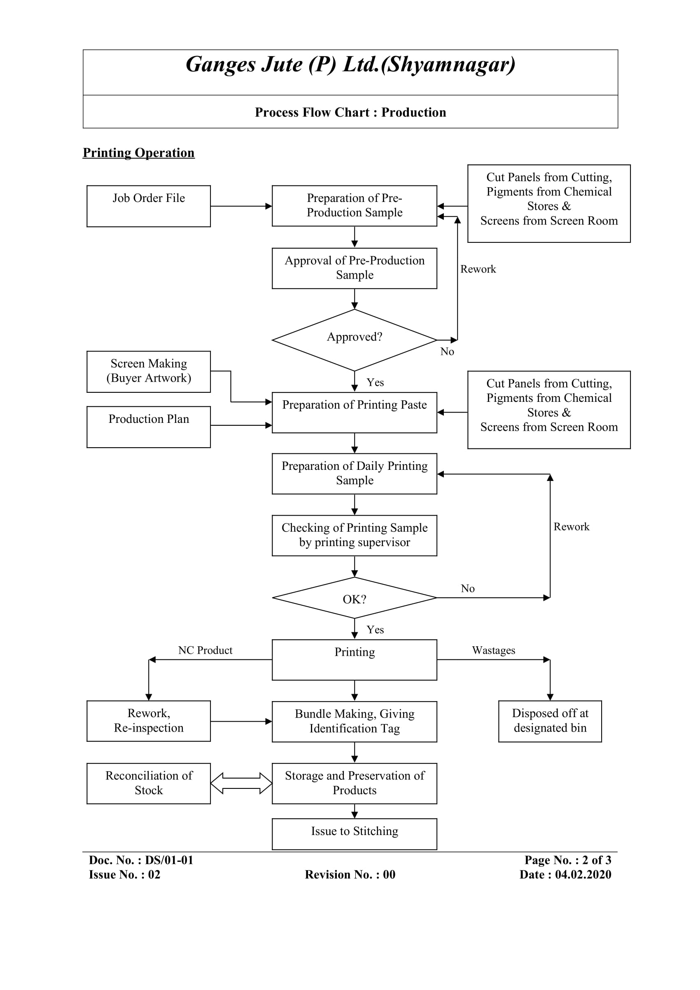

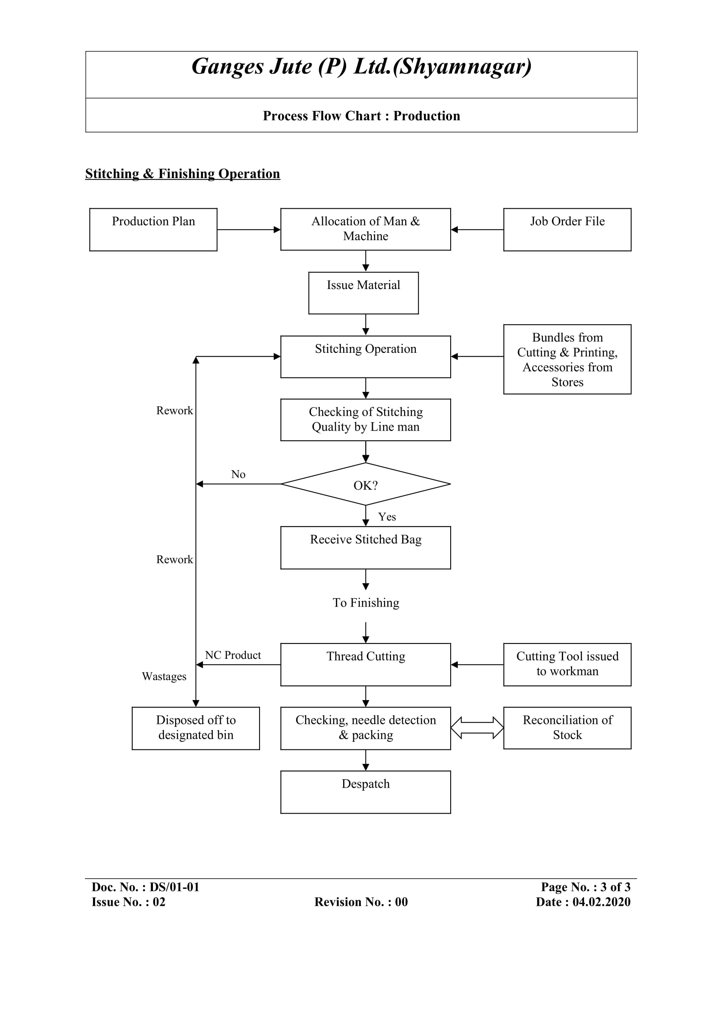
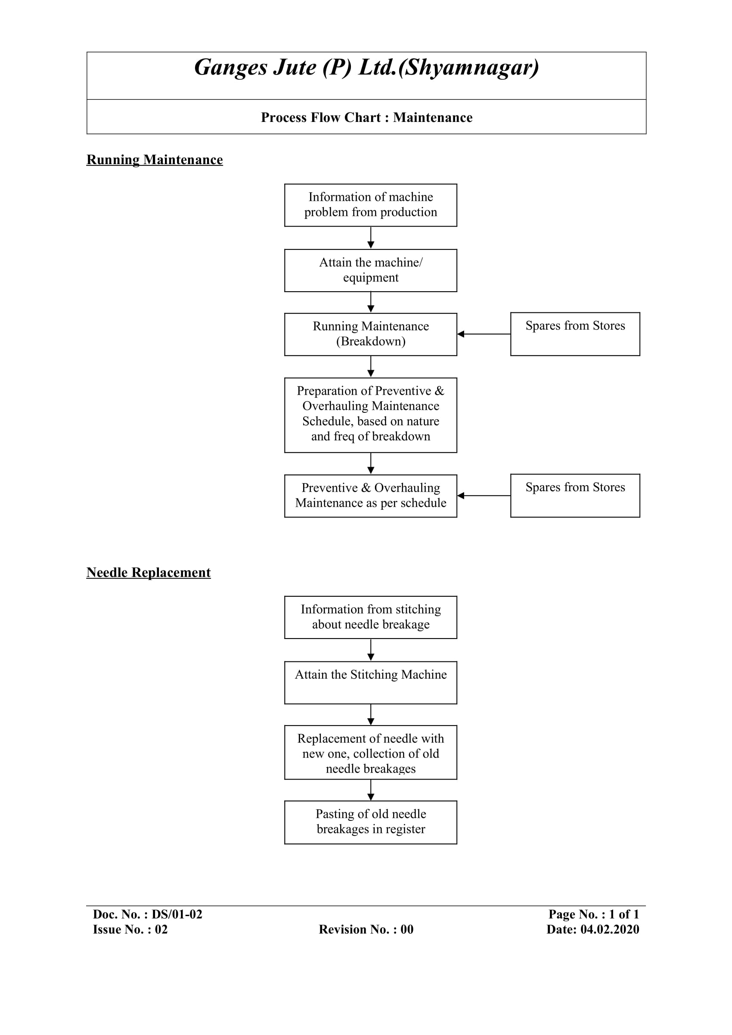

HANDLING COMPLAIN AND SUGGESTION:
Customer Complain or Suggestion or Complain receive from Complain Box or Employee

Investigation of Complaints by General Manager

Respective Dept. would be given the responsibility for handling the Complaint

Action taken by respective Dept.

Review effectiveness of Corrective action after implementation

Closing of Complain or suggestion

- Process:
- Customers would be intimated about their right to complaint or Suggestions to the Management – Ganges Jute (P) Ltd.
- Ganges Jute (P) Ltd. factory would have complain / suggestion box where complaints and suggestions can be directly forwarded to the General Manager, Bag Unit, Ganges Jute (P) Ltd.
- Upon entry of complaint information through Complain or Suggestion Box, notification will be submitted to Management regarding complain.
- All such written complaints drawn in Suggestion Box would be received either by General Manager or by Compliance Officer, Ganges Jute (P) Ltd. and noted in the Customer Complaint File / Register maintaining a serial number of the same.
- Complaints must be reviewed and classified on the responsibility basis.
- Company will review each complaint or suggestion to determine if immediate action is needed.
- Factory will initiate a complaint Register that will include the all-input data. One file is also maintained in which the other documentation, including: investigations, photographs, memos, and final close‐out documentation will be carry on.
- Actions taken for such complain would be documented and same would be retained for the organization’s learning experience.
- General Manager – Ganges Jute (P) Ltd. would be responsible to oversee that the implementation of corrective and preventive actions is ensured.

MONITORING OF INTERNAL CONTROLS AND EFFECTIVENESS

- Regular Audits and Inspections:
Ganges Jute conducts regular internal and external audits to monitor the effectiveness of the measures implemented to prevent child labor, forced labor, and human trafficking. These audits assess compliance with the company's ethical labor policies and help identify any gaps in internal controls. Unannounced audits may also be carried out to ensure ongoing compliance and transparency, and to address potential human rights violations promptly.
- Risk Assessments:
Regular risk assessments are conducted to identify potential areas where child labor, forced labor, or human trafficking risks might arise. These assessments help the company implement targeted preventive measures and closely monitor high-risk areas. Mitigating human rights violations is a key focus during these assessments, ensuring that any risks related to labor exploitation are addressed proactively.
- Employee and Vendor Training:
All employees, especially those involved in recruitment and vendor management, undergo training on identifying signs of child labor, forced labor, and human trafficking. This ensures that staff are aware of their responsibilities and can spot potential risks early. Vendors and suppliers are also required to adhere to the company’s strict anti-labor exploitation policies, with regular assessments of their practices.
- Supplier Audits and Evaluations:
Third-party audits of suppliers and subcontractors are conducted regularly to ensure compliance with labor laws and company policies on preventing child labor and forced labor. These audits help verify that suppliers follow ethical labor practices and meet contractual obligations to prevent human trafficking. External audits offer an impartial evaluation of the company's practices and help identify areas for improvement.
- Grievance Mechanism and Reporting Channels:
Ganges Jute provides a confidential grievance mechanism and whistleblower procedure that allows employees and contractors to report concerns about labor violations, including child labor or human trafficking. Reports are investigated promptly, and appropriate actions are taken to address any issues raised.
- Tracking and Reporting:
The company maintains detailed records of all monitoring activities, including audit results, risk assessments, and corrective actions taken. These records are reviewed regularly to measure the effectiveness of internal controls and to make improvements where necessary. Regular tracking ensures that any human rights violations are addressed swiftly and that the company remains compliant with ethical standards.
- Collaboration with External Agencies:
Ganges Jute collaborates with local government agencies, NGOs, and international organizations to strengthen its efforts in preventing child labor, forced labor, and human trafficking. This collaboration ensures alignment with national and international standards and provides additional resources for monitoring and improvement.

GREVIANCE & REMEDIATION MECHANISM

Grievance Mechanism

- Reporting Channels
Ganges Jute Pvt. Ltd. offers multiple confidential reporting channels for employees to raise grievances or report incidents. These channels include:
  - Dedicated Hotline: +91 9051155858
  - Confidential Email: whistleblower@gangesjute.com
  - Grievance Boxes located in common areas for anonymous submissions.
  - Online Platform: www.gangesjute.com/whistleblower-report
- Types of Grievances Covered
The mechanism covers grievances related to:
  - Discrimination based on gender, race, religion, ethnicity, disability, or any other characteristic.
  - Harassment, including physical, verbal, sexual, or psychological abuse.
  - Child labor violations or risk of exploitation.
  - Forced labor and human trafficking incidents.
  - Unsafe working conditions.
  - Breach of labor rights including wage theft or unlawful termination.
- Grievance Submission Process
  - Employees can submit grievances confidentially through the reporting channels.
  - Reports should include as much detail as possible, such as the nature of the grievance, individuals involved, dates, and any evidence.
  - Anonymous submissions are accepted, and whistleblowers are protected from retaliation.
- Investigation Process
  - Upon receipt of a grievance, the Grievance Committee or HR department initiates an investigation. Investigations are handled by trained personnel to ensure impartiality.
  - Initial response is provided within 5 working days and investigations are typically concluded within 15 working days.
  - Relevant parties are interviewed, and evidence is reviewed to determine the appropriate course of action.
- Non-Retaliation Policy
  - Ganges Jute maintains a strict non-retaliation policy. Employees who report grievances are protected from any form of retaliation, including demotion, dismissal, or harassment.
  - Disciplinary action will be taken against anyone found retaliating against whistleblowers.
- Appeal Process
  - If the employee is dissatisfied with the outcome of the investigation, they can file an appeal with senior management.
  - Appeals are reviewed by senior management or an independent third party, and further action is taken as necessary.
- Training and Awareness
  - Regular training programs are conducted to educate employees about the grievance mechanism, their rights, and the importance of reporting misconduct.
  - Awareness campaigns are held to promote a culture of openness and transparency within the organization.

Remediation Procedure for Specific Issues

- Purpose and Scope
- Ganges Jute Pvt. Ltd. has established a structured remediation process to address, resolve, and prevent issues reported through the grievance mechanism or identified through audits and inspections.
- This process ensures that any harm caused to individuals is appropriately addressed and corrective measures are implemented to prevent recurrence.
- Remediation Committee
- A Remediation Committee is constituted to evaluate investigation findings and determine appropriate corrective and preventive actions.
- The committee includes representatives from HR, Compliance, and senior management, depending on the severity and nature of the issue.
- The committee ensures fairness, consistency, and alignment with company policies and legal requirements.
- Scope of Issues Covered Under Remediation
The remediation process applies to all ESG-related concerns, including:
- Working Conditions
- Correction of unsafe conditions, improvement of workplace facilities, Employee Health and safety and adjustment of working hours or wages
- Social Dialogue
- Restoration of worker rights related to association, communication, and participation
- Career Management and Training
- · Rectification of unfair practices in promotion, appraisal, or training access
- Child Labour, Forced Labour and Human Trafficking
- Immediate withdrawal from non-compliant practices
- Support for affected individuals including education, rehabilitation, or financial assistance
- Discrimination and Harassment
- Disciplinary action against offenders and support to affected individuals
- Workplace adjustments to ensure a safe environment
- Anti-Corruption and Ethical Conduct
- Investigation and disciplinary action in cases of misconduct
- Strengthening internal controls and ethical practices
- Responsible Information Management
- Corrective actions for data breaches and strengthening of data protection measures
- Proportionality of Response
  - Remedial actions are determined based on the severity, impact, and frequency of the violation.
  - Actions may include disciplinary measures, compensation, policy revisions, or operational improvements.
  - Special care is taken to address impacts on vulnerable individuals.
- Transparency in Communication
  - The company ensures transparent communication regarding remediation actions with relevant stakeholders while maintaining confidentiality.
  - Affected individuals are informed about the progress and final outcome.
- Remediation Timeline
  - Remediation actions are initiated immediately after investigation.
  - Most cases are resolved within 15–30 working days, depending on complexity.
  - Continuous updates are provided until closure.
- Monitoring and Effectiveness
  - The effectiveness of remediation actions is monitored through follow-ups, audits, and feedback from affected individuals.
  - Preventive measures are implemented to avoid recurrence and improve systems.
- Support to Affected Individuals
Ganges Jute Pvt. Ltd. provides appropriate support, which may include:
- Medical care and health support
- Counselling and psychological support
- Financial assistance where applicable
- Workplace protection, reassignment, or adjustments
- Documentation and Record Keeping
All remediation actions are documented and maintained for compliance, audit, and continuous improvement purposes.
- Records include details of the issue, investigation findings, actions taken, and closure status.

WHISTLEBLOWER PROCEDURE

- Purpose and Scope
The whistleblower procedure at Ganges Jute Pvt. Ltd. aims to encourage employees to report unethical behavior, misconduct, or violations of company policies without fear of retaliation. This procedure applies to all employees, contractors, and stakeholders.
- Confidential Reporting Channels
Ganges Jute provides multiple confidential reporting channels for whistleblowers. Employees can report concerns through:
- A dedicated hotline: +91 9051155858 managed by a third party to ensure anonymity.
- An email: www.gangesjute.com/whistleblower-report address specifically designated for whistleblower reports.
- A secure online platform: www.gangesjute.com/whistleblower-report for submitting reports.
All reports made through these channels will be treated with the highest confidentiality.
- Reporting Process
Employees are encouraged to provide as much detail as possible regarding the misconduct, including dates, locations, individuals involved, and any evidence available. Reports can be made anonymously if preferred, but providing contact information may help in follow-up investigations.
- Investigation Procedures
Upon receiving a whistleblower report, Ganges Jute will initiate an internal investigation promptly. Investigations will be conducted by designated personnel trained in handling such matters. The investigation process will include interviewing relevant parties, gathering evidence, and ensuring that the whistleblower's identity is protected throughout the investigation.
- Non-Retaliation Policy
Ganges Jute has a strict non-retaliation policy to protect whistleblowers from any form of retaliation, including harassment, discrimination, or punitive actions. Employees who report concerns in good faith will be shielded from retaliation, and any retaliatory actions will be subject to disciplinary measures.

- Follow-Up and Communication
After the investigation is concluded, the whistleblower may receive a summary of the findings and any actions taken, unless disclosure could compromise confidentiality or legal requirements. Employees are encouraged to remain engaged and report any further issues related to the initial complaint.
- Training and Awareness
Ganges Jute conducts regular training sessions to inform employees about the whistleblower procedure, the importance of reporting misconduct, and their rights under this policy. Awareness campaigns are also implemented to create a culture of openness and transparency within the organization.
- Situations for Reporting
The whistleblower procedure can be utilized in various situations, including but not limited to:
- Information Security Violations: Reporting breaches of data protection policies or unauthorized access to sensitive information.
- Corruption and Fraud: Reporting instances of bribery, embezzlement, or any unethical behaviour that compromises the integrity of financial reporting.
- Harassment and Discrimination: Reporting workplace harassment, bullying, or discrimination based on gender, race, religion, or other protected characteristics.
- Health and Safety Violations: Reporting unsafe working conditions or failure to adhere to health and safety regulations.
- Environmental Violations: Reporting non-compliance with environmental regulations that could harm the environment.
- Violation of Company Policies: Reporting breaches of internal policies or procedures, such as conflicts of interest or misuse of company resources.
- Retaliation Against Whistleblowers: Reporting any retaliatory actions faced by employees for reporting concerns.

LIST OF POLICIES

Sr. No | Policy Name
1 | Quality Policy
2 | Ethic Policy
3 | Child labor Policy
4 | Social Policy
5 | Disciplinary Measures Policy
6 | Tools Policy
7 | Hygiene Policy
8 | OHS Policy
9 | Environmental Policy
10 | Discrimination and Harassment Prevention Policy
11 | Collective Bargaining Policy
12 | Anti-Harassment Policy
13 | Freedom of Association Policy
14 | BRC Consumer Product Policy
15 | BRC Glass Policy
16 | BRC Needle Policy
17 | BRC Jewelry Policy
18 | BRC Visitor Policy
19 | Training Policy
20 | Wages and Hours of work Policy
21 | Broken Needle Policy
22 | BRC implementation Policy
23 | Human Right Policy
24 | Sustainability Policy
25 | Forced & Prison Lamour Policy
26 | Sustainable Procurement Policy
27 | Living Wage Policy

SUMMARY

As mentioned earlier, this induction training manual is more of a guide on interpretation and understanding the requirements of the company’s standard. Since the quality and environment is a dynamic phenomenon, there is no finish line and there is always a scope for improvement in every product or activity and the same is applicable to this book also.
The induction procedures and guidelines aim to set out general steps for
employees to follow during the induction process. All employees are expected to adhere to these procedures.

It is the aim of GANGES JUTE PVT. LTD. To ensure that employee’s induction training is dealt with in an organized and consistent manner so that employees can be introduced into a new post and working environment quickly and therefore contribute effectively and efficiently as soon as possible. Wages to be calculated based on Living wages guidance which is conforming to the requirement of Minimum wages act.

Wages disbursement to be done on fortnight basis for workers and monthly for staff. Other benefits like ESI, PF, Gratuity, Bonus, Leave, Maternity leave, Crèche and subsidies food facility including onsite medical facility and ambulance available.

“PRACTICE IS THE HARDEST PART OF LEARNING, AND TRAINING IS THE ESSENCE OF TRANSFORMATION.”

